The Yetholm Parish Militia Club
It was a time of great change. The Royal Family’s affairs, especially the alleged misconduct of the prospective Queen, whose royal husband sought a divorce, was being publicly exposed in lurid detail in the popular media. A National Lottery was in full swing, making winners fabulously rich. An insurance scheme set up to ward off one misfortune for households, had a built in excess on any claim.
The year, however, was not 1996 but 1820; the royal husband was George IV, who was heading for a coronation from which his wife Caroline was to be excluded. The media were the newspapers, as now, and in place of television were the coloured prints. Could things like these possibly happen in our day and age, including accusations of marital impropriety in the Royal Family, aired week after week in the Press?
Among the advertisements in the Kelso Mail at that time, and alongside the announcement of a Rich Wheel (a lottery with shares to be sold throughout Scotland at Post Offices, stationers, etc.) was one stating that groups of distinguished citizens had been prevailed upon to advertise a declaration in support of the King and the Monarchy. Loyalty was to be shown by signing this declaration at the Town Hall, Kelso, and other towns in the Borders. Today we are more accustomed to signing books of condolences, and this throws light on the need of extra support which some felt the Monarchy had at that time and is part of the background to the maintenance of a militia, and therefore relevant to my subject.
At least it was a constitutional Monarchy, as well as a Protestant one, this having been established by the Revolution" in 1688. Both Whigs and Tories were determined to keep out any Catholicism and maintain the power of Parliament. Political power was increasingly in the hands of the people but economic power remained with the nobility, landowners, mill and ship owners and those who were able to profit from exploitation of colonial resources such as sugar and tea plantations.
With the French Revolution and the Napoleonic Wars came the threat of invasion. The British Government sought to deter threatened rebellion at home and also free the Regular Army for action abroad. The militia which had developed over centuries was therefore strengthened, and in 1797 the Scottish Militia Act authorised the conscription by ballot of a Militia of ,000 men aged between 18 and 30. The upper age limit was extended to 45 in 1802. The period of service was apparently five years.
Earlier militias, even whole units, had usually been provided by landowners from their families and tenants. The Glorious Revolution" having preserved the class system intact, it was to the landed gentry that command of the Militia was now entrusted, in the understanding that they had most to preserve. There was already much resentment of the army throughout Scotland (it was only fifty-one years since Culloden, and having to serve under the gentry and on behalf of the Government provoked further unrest.
The parish schoolmaster was required to draw up a list of those eligible for the ballot, which was then displayed on the door of the kirk with intimation of the days on which the Deputy Lieutenant of the County would attend to hear claims for exemption from service in the Militia.
Those persons exempt from Militia service included clergymen, schoolmasters, university professors, articled clerks, apprentices, seafarers and all those with two children born in wedlock. Anyone chosen in the ballot could provide a substitute or could pay £10 to be excused – a not inconsiderable amount for a working man at that time!
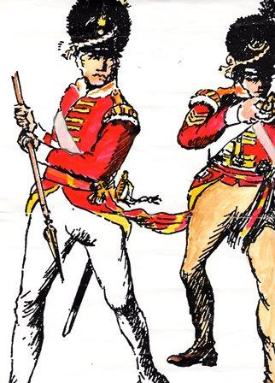
The Act of 1797 was seen by many as an attack on the workers and poorer people. There were violent disturbances in protest, especially at Tranent in 1797 and Ruthven Parish in 1803. In some areas lists were torn down from the kirk doors and parish registers were forcibly removed from the schoolmaster’s house. In Selkirk, mobs from Melrose and Galashiels drove the deputies out of town, and in Jedburgh some rioters were jailed.
Eventually the law-abiding citizenry bowed to the authority of King and Parliament. The Border regiments of Dumfries, Selkirk and Roxburghshire had been combined in 1802 as the Dumfries Militia (uniforms shown on the left). The Militias took no active part in the wars, but had released the Regular Army for foreign duties. The Dumfries Militia were admired wherever they went for their superior discipline and exemplary conduct, and the Government for its part felt the need to maintain the Militias in the face of continued unrest after the war, although they were seldom called out for training. One such muster of about 400 men took place in June 1820.
From the Kelso Mail, 4th October 1821:
“CAUTION TO MILITIAMEN - We formerly stated that six men were apprehended as deserters from the Dumfries-shire, c Militia: three of whom were a few days ago committed to the Jail of this place, for the period of twelve months, in terms of the Act of the 42nd Geo. III Cap. 91, viz: six months for having enlisted into the Regular Army since their engagement with the Militia, and six months for having absented themselves from the training of the regiment in June last. In addition to this they have to serve five years more in the Militia, and afterwards fulfil their engagements with the Regular Army. Two of the above were marched, as deserters, upwards of 400 miles. – Dumfries Journal."
Prior to this a ballot had to be held at the Town Hall, Kelso on 20th and 27th October 1820 to supply the deficiency in the Dumfries Regiment of Militia in respect of one substitute from the 1816 ballot, George Lamb, who had deserted the Militia and enlisted in a Regular Regiment now lying off Gibraltar, and one Bernard Common, a Jedburgh stocking maker, who had been banished from the County of Roxburgh by the Sheriff and was lurking in the vicinity of Wooler."
In some parishes, such ballots had prompted the formation of insurance societies, through which by regular payments over the period of a ballot, those liable might find a substitute, or receive some compensation if they decided to serve.
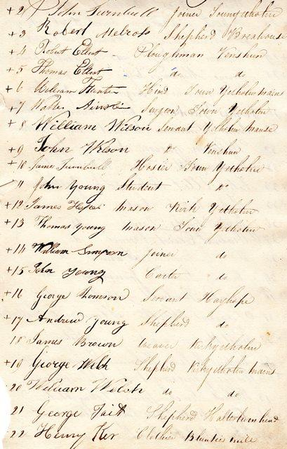
Owing to the generosity of the late Mr Jack Robb, formerly of Bluntys Mill, Kirk Yetholm, we hold in the Bill Rae Archives of YHS the original minute-book of the Yetholm Parish Militia Club, 1820-31. This eloquent document brings to life elements of life in this Parish through the proceedings and personal signatures, occupations and addresses of upwards of 92 Yetholm men between 18 and 45 years of age who were members of that Club almost two centuries ago (some of their signatures, with their residence and occupation, can be seen on the left). These are a valuable resource for expatriates researching their ancestry, and some are forebears of people still residing in the area of Town and Kirk Yetholm. The various occupations of these parishioners paint a picture of a self-contained world which is nevertheless deeply affected by world events.
The minute book begins: "A Meeting of Persons of the Parish of Yetholm liable for the regular Militia of Scotland held at Town Yetholm in the Schoolhouse on 18th May 1820 for the purpose of establishing a Club in order to provide funds for the procuring of Substitutes to serve in the room of such of the members of the Club as might be ballotted to serve in said Militia Force." Mr George Henderson, a merchant, was installed as Presses" and William Henderson, teacher, as Clerk. By 25th May they had drawn up a clear set of Laws for approval at a General Meeting on the 27th when James Ainslie, Baker, was made Presses, and William Henderson was also appointed Treasurer at £1:1- stg annually. Initially there were 46 members.
It must be said that the affairs of the Club were conducted with the utmost precision, the money for distribution being calculated even down to the 55th part of a penny! It is not clear how these fractions could be paid, but they were due under the Laws of the Club.
The entry money was 10/, with 2- to be paid half-yearly. If a member was called up by the ballot and the Club found a substitute for him he still had to pay the excess of 10/-. The Club would pay a suitable substitute :1. Substitutes were found by intimation in both Town and Kirk Yetholm of vacancies (the Town Crier was paid a fee of 1) Should a member choose to serve, or to be a substitute for another member, he would then receive the
If the Treasurer found himself in possession of £10 he should put it to interest in the Bank of Scotland in the name and for the benefit of the Club."
The Club instructed whoever was to attend the October ballot to pray the Lieutenancy not to call upon Yetholm for men but to have the missing Militiamen apprehended and compelled to fulfil their duties. The sum of 5/was paid to the Clerk for preparing this petition, and the expenses for paper and a reasonable days wage for whoever should travel to the ballot in Kelso were all carefully accounted for. Unfortunately His Lordship declined the prayer as far too late, and the ballot was to proceed.
One of the members, John Elliot, a baker in Town Yetholm, was chosen in the ballot and at a Managers' meeting on 2nd November William Simpson, a joiner in Town Yetholm and also a member, agreed to substitute in his place. He would then receive the bounty, less the excess. Persons who were balloted and not members were not the concern of the Club and though they are listed they took no part in the proceedings.
By 27th October the following year the finances were all settled and the balance of subscriptions repaid to retiring members. One or two more meetings were held and by 26th April 1823 it was agreed the prospect of a ballot was now remote. In the event of another ballot the Secretary should keep the books open and call a meeting to reconstitute the Club. On 3rd May 1823 the balance was :15/9d plus a farthing which was 16/2d three farthings plus ten elevenths of a penny due to each remaining member. There is no mention of how the fractions were paid
The next Drill, of 27 Officers and 520 Men again under the Marquis of Queensberry, was to be at Dumfries from 25th June to 22nd July 1825, and required a ballot for 5 men. A meeting was called in Yetholm and the Club was re-established with 57 men on 23rd April 1825. These meetings were generally at 8pm which may reflect the long working day as well as the time of the evening meal. Thomas Young, a mason of Town Yetholm, and Adam Tarbit of Halterburnhead were the members balloted this time. George Moffat, a shoemaker of Yetholm and William Young, shoemaker of Kelso, were to be substitutes. They were paid 1- on acceptance by the Club, the bounties being retained until they were approved and attested for the Militia.
On 29th October 1825 the amount due to the remaining members was /6d and 24 fifty-fifths of a penny each!
The Regiment seems to have virtually ceased to function after the Drill of 1825. In 1828 the Officers who had served with the Regiment since the war sold most of the mess plate among themselves for , a little more than its value. They could see little likelihood of the Militia being active again. The proceeds were distributed to the officers in shares proportionate to their contributions to the mess.
Another ballot was still required in March 1831 and the Yetholm Militia Club was again reconstituted. Five Yetholm names were drawn, of whom one, John Dickson, labourer of Kirk Yetholm, was not a member. From the Club, those balloted were: from Kirk Yetholm, George Wilson, merchant and James Allan, a servant; and from Town Yetholm, William Grahamslaw, farmer and Adam Oliver, a shoemaker. All four chose to be substituted. Public intimation was made in both villages as before and the substitutes found were Adam Cockburn, labourer, for George Wilson; John Kelly, shoemaker, for James Allan; Andrew Young, labourer, for William Grahamslaw; and William Mills, servant, for Adam Oliver. All came from Town Yetholm and were paid the enlisting money" of 1- each. It had now come to light that other Militia Clubs were much less generous than Yetholm, and the all important bounty was reduced to :10/. The substitutes were conducted to Kelso by George Wilson and John Kerr to see them examined and sworn in.
There followed one of the most interesting episodes in the Club. On 23rd March 1831 it came to the managers' notice that Andrew Young, substitute from Kirk Yetholm, intended to go to America so soon as he received the bounty. Cited before the meeting, he was examined and in order to remove all doubts he offered to allow his bounty to remain in the hands of the Treasurer till the Regiment was embodied, as security for his appearance. This was accepted but he was to be paid 10/- when he was attested.
The Dumfries Militia underwent successive cuts until 1854, when its establishment was modified under the Militia Act of that year. The uniforms, clothing (now worn out, swords, muskets and bayonets etc. were all sent for storage at Carlisle Castle and by 1855 the only firearms of the Regiment (now known as No. 81) were six fusils. Under the earlier Acts the Militia could be embodied when there was danger of invasion or insurrection. Now this would only apply whenever there was war with a foreign power. During the Crimean War, the Militia was raised by voluntary enlistment. The total quota for Dumfries, Roxburgh and Selkirk was 512 but it appears the muster parade was a sad sight as it was very hard to recruit. The Marquis of Queensberry, Colonel of the Regiment, had to resort to recruiting his own labourers. Training improved the troops greatly but the momentum of the Napoleonic Wars had gone.

